POM 14 – Global Collaboration

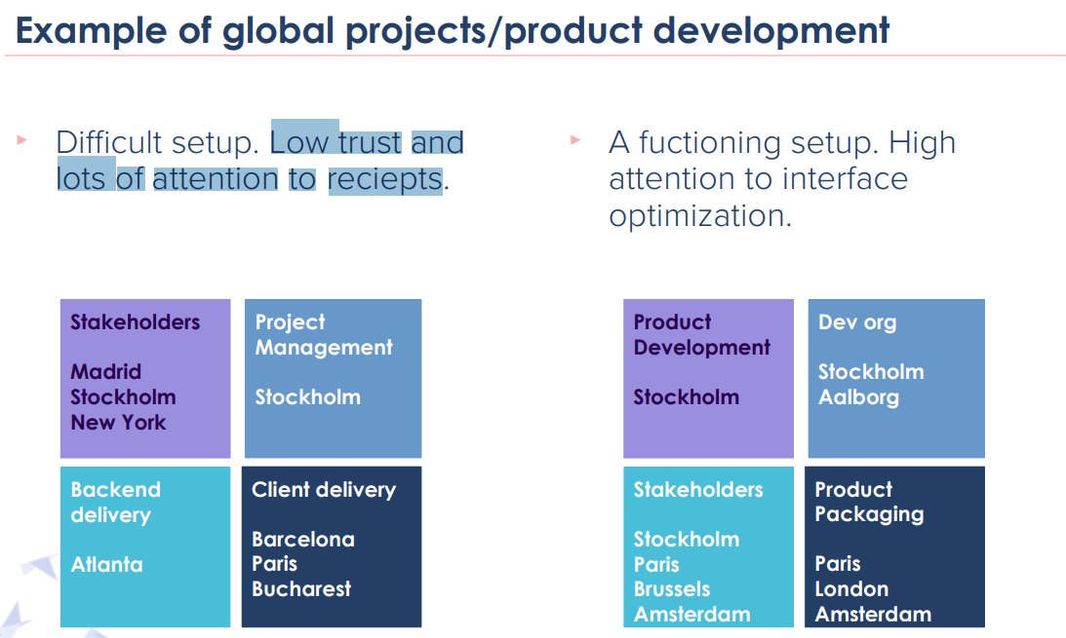

**Communication**

* Its very important for a successful project delivery and product development
  + Impossible to deliver value without communication
  + Active & conscious (bewusste) communication will make most projects successful
* Lack of communication is one of the biggest reasons for people performing bad and not enjoying work

**Communication patterns**

* Planned vs unplanned
* Synchronous vs asynchronous
* Vertical vs horizontal
* Formal vs informal
* Internal vs external stakeholders

**Communication challenges in global contexts and mitigation**

* Who to contact – roster
* Difficulty of initiating contact – document communication structure
* Language – explain back to each other
* Ineffective communication – be aware in communication strategy
* Lack of informal communication – build relationships

**Tools to enable communication ???**

* Invest in tech
* Plan for online & offline
* Technical issues
* Office facilities
* Combining live communication and remote
* Tracking of communication

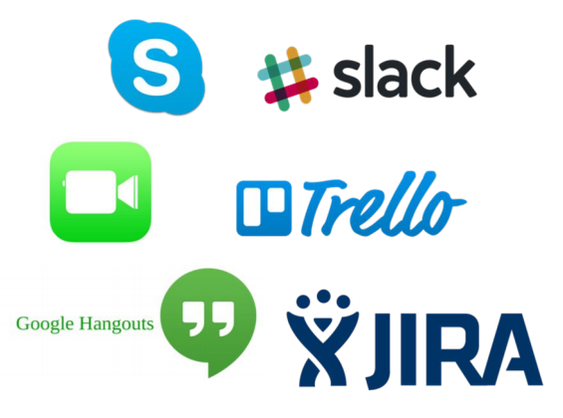

**Travel!**

* Invest in meeting face to face
* Have a satellite in the other location, channeling things
* When budgeting the project always argue for the travel budget
* Compensate for climate effects!

**Practical tips on communication in global contexts**

* Focus on more planned communication
* Make sure to schedule time for synchronous communication
* Easily accessible meeting notes
* Invest in tools/facilities to enable informal communication
* Create a mindset of awareness and respect of time difference
* Invest in travel

**Differences in product development vs projects**

|  |  |
| --- | --- |
| Product development | Projects |
| * Done with long term organization and with no decided end date   + Invest in long term productivity | * possible to create small teams for a short period of time for short term delivery   + high investment – high energy |
| * adds dependencies by size and product lifecycle   + IT architecture is important | * can more easily free themselves from patterns and habits and focus on the project goal |

**Architecture and infrastructure for global contexts**

* Think smart when “Slicing the Elephant”
  + Split the responsibility in small parts to keep the dependencies low
* If possible, choose an architecture that enables distributed teams
* Continuous integration to avoid planning dependencies

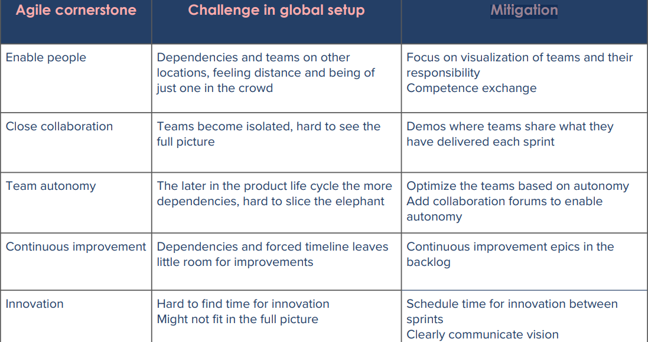

**Practical tips to enable agile methodologies in a global setup**

* Add extra collaboration forums
* Keep teams in one location
* Make sure the teams know about each other and share knowledge between teams
* Make sure to plan for daily cooperation business people

**Collaboration Forums ????**

* Team meetings (daily standups, retros, reviews, etc.)
* Alignment meetings (scrum of scrums, po forums, stakeholder forums, etc.)
* Status meetings (demos, planning sessions, etc.)
* Knowledge forums (presentations, workshops, brainstorming sessions, etc.)
* Networking forums (team breakfasts, lucky lunches, hangout coffees, etc.)